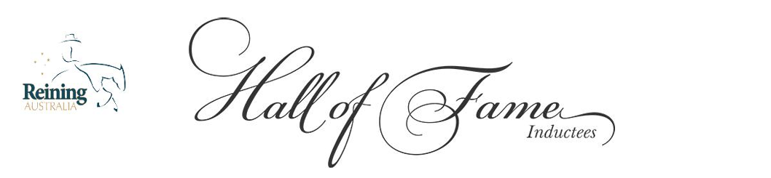
Reining Australia – Meritorious Service Award Nomination Form

Celebrating the People Who Built Our Sport
Every great sport is shaped not only by its champions in the arena, but by the dedicated individuals who work tirelessly behind the scenes. The Reining Australia Meritorious Service Award honours those exceptional people whose commitment, leadership, and voluntary service have strengthened our organisation and helped build the foundation on which Australian reining stands today.
These are the individuals who give their time without expectation, who step forward when others step back, and who consistently uphold the values, integrity, and vision of Reining Australia. Their contribution is not measured in points or placings, but in impact, dedication, and legacy.
Receiving a Meritorious Service Award is one of the highest honours bestowed by Reining Australia. It recognises a level of service that has shaped our community, advanced our objectives, and left a lasting imprint on the sport we all love.
Nominations are open year-round.

SECTION 1 — NOMINEE DETAILS
Nominee Name:
Email (if known):
Phone (if known):
Roles or Capacity in Which They Served: (Committee roles, volunteer positions, event support, governance contributions, program development, etc.)

SECTION 2 — NOMINATOR DETAILS
Nominator Name:
Reining Australia Membership Number:
Email:
Phone:
Relationship to the Nominee (if any):

SECTION 3 — SERVICE CONTRIBUTION & IMPACT
Description of the Nominee’s Contribution: (Outline the individual’s voluntary service, roles, responsibilities, and impact.)
Significant Achievements or Milestones: (Examples: event leadership, committee service, organisational improvements, long-term volunteer commitment.)
How Their Service Has Advanced Reining Australia’s Objectives:

SECTION 4 — SUPPORTING MATERIAL
You may attach: • Letters of support • Service records • Testimonials • Photos • Historical documents • Media articles • Any additional evidence of contribution
List of Attachments Provided:

SECTION 5 — DECLARATION
I declare that the information provided in this nomination is true and correct to the best of my knowledge.
Signature: ___________________________________________
Date: ________________________________________________

RETURN COMPLETED NOMINATION FORM TO:
Reining Australia Secretary 📧 secretary.reiningaustralia@gmail.com

