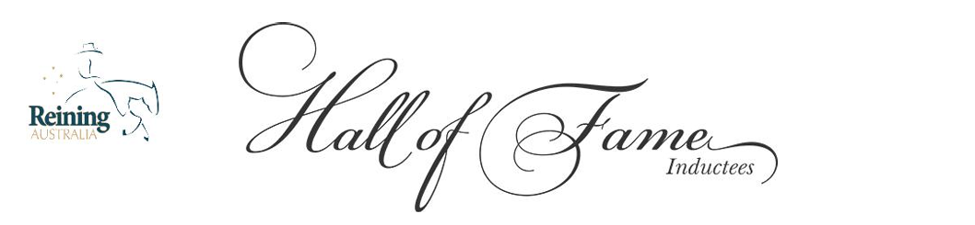
Reining Australia Hall of Fame – Honouring the Legends of Our Sport
Some horses don’t just compete, they define an era. The Reining Australia Hall of Fame celebrates the extraordinary athletes whose talent, heart, and impact have shaped the very foundation of reining in this country. These are the horses that changed what was possible, lifted the standard for everyone who followed, and left an enduring legacy in the arena and beyond.
Induction into the Hall of Fame is the highest honour Reining Australia can bestow. It recognises a horse whose influence reaches far beyond ribbons and records — a horse remembered for brilliance, consistency, courage, and the unforgettable moments they gave our sport.
Each year, we honour new inductees during the Reining Australia Gold Buckle Futurity and National Show, where the entire community comes together to celebrate the legends who built the path we ride today.

Hall of Fame (Horse) Nomination

Eligibility to Nominate
Any financial member of Reining Australia may nominate a horse for Hall of Fame consideration. Nominations are open year-round and may be submitted at any time to the Hall of Fame Committee.

Selection Process
All nominations undergo a detailed review by the Hall of Fame Committee. Final inductees are selected by the Reining Australia Board of Directors and formally recognised at the Gold Buckle Futurity and National Show.

Assessment Criteria
When evaluating a nomination, the following areas may be considered:

Competition Excellence
A comprehensive record of the horse’s achievements in Reining Australia competition, including:
- National and State titles
- Show results
- Money earned
- Consistency, longevity, and overall impact in the arena

Contribution to the Sport
The horse’s influence on the reining community, including:
- The excitement and enjoyment they brought to spectators and competitors
- Their role in elevating the standard of competition
- Their presence as a defining athlete of their era

Retirement Status
The horse must be retired from competition or may be deceased.

Reining Australia – Hall of Fame (Horse) Nomination Form

Honouring the Legends of Our Sport
Induction into the Reining Australia Hall of Fame is the highest honour awarded to a horse in Australian reining. This form allows financial members to nominate an exceptional horse whose achievements, influence, and legacy have shaped our sport.
Nominations are open year-round.

SECTION 1 — HORSE DETAILS
Horse Name:
Breed:
Reining Australia Competition Number:
Date of Birth (if known):
Sex: □ Mare □ Stallion □ Gelding
Owner(s) (current or last recorded):
Retirement Status: □ Retired from competition □ Deceased □ Unknown

SECTION 2 — NOMINATOR DETAILS
Nominator Name:
Reining Australia Membership Number:
Email:
Phone:
Relationship to the Horse (if any):

SECTION 3 — COMPETITION RECORD & ACHIEVEMENTS
Reining Australia Competition History: (Include National and State titles, major wins, notable placings, lifetime earnings, and significant milestones.)
Other Relevant Performance History: (Club shows, special awards, standout performances, or achievements outside RA competition.)

SECTION 4 — CONTRIBUTION TO THE SPORT
Impact on Competitors and Spectators: (Describe memorable performances, consistency, longevity, or influence on the sport.)
Legacy and Influence: (How this horse shaped the sport, inspired riders, or elevated competition standards.)

SECTION 5 — SUPPORTING MATERIAL
You may attach:
- Show records
- Earnings summaries
- Photos
- Videos
- Testimonials
- Historical documents
- Media articles
List of Attachments Provided:

SECTION 6 — DECLARATION
I declare that the information provided in this nomination is true and correct to the best of my knowledge.
Signature: ___________________________________________
Date: ________________________________________________

RETURN COMPLETED NOMINATION FORM TO:
Reining Australia Secretary 📧 secretary.reiningaustralia@gmail.com

